NATIONAL ABORIGINAL ROAD SAFETY VIDEO PROJECT TEAM
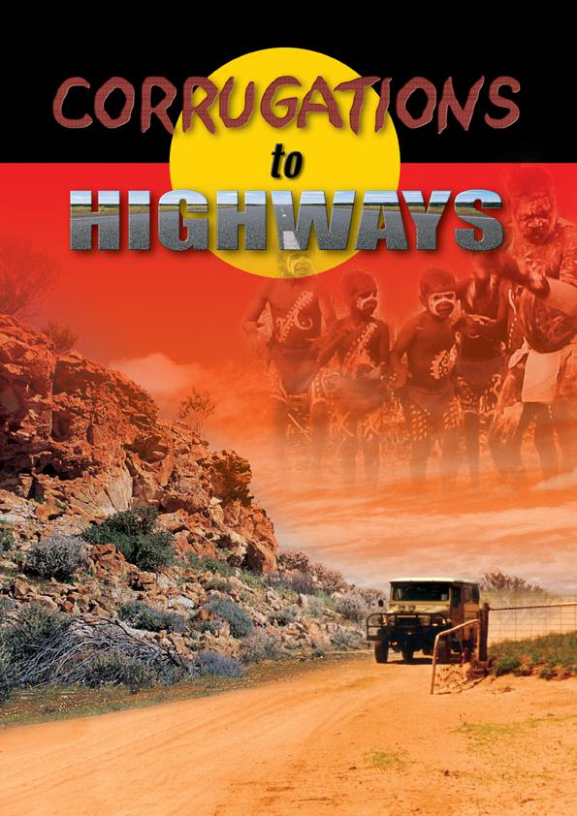

C/- Local Government House, 15 Altona Street, WEST PERTH WA 6005
PO Box 1544, WEST PERTH WA 6872
Telephone: (08) 9213 2066

Facsimile: (08) 9321 8378

Email: roadwise@walga.asn.au

NATIONAL ABORIGINAL ROAD SAFETY VIDEO

ORDER FORM

Contact details of person ordering resource

Name

Position

Telephone contact

Mobile

Email address

Organisation

Name

Postal Address

No. of Packs required

If the resource is being used to complement an existing road safety/driver training program, could you please indicate details of the program below.

If using the resource to teach road safety to school students, could you please indicate details of

FAX THIS FORM TO

ROADWISE
Fax Number: (08) 9321 8378 Please allow two weeks for delivery

